**Bluetooth Controlled Door Lock Using Arduino**

**Project Report**

**Submitted for the course:**

**CSE-3001 Internet of Things**

**By:**

**Mayank Verma 15BCE0032**

**Submitted to:**

**Prof. Anand M.**

**(SCOPE)**



**Abstract**

This project emphasizes remotely controlling the lock of a door wihout the actual use of keys. Such kind of innovation fulfils the needs of people with physical disabilities at home and it also eliminates the anxiety to lose the door keys.It uses the Bluetooth technology to establish communication between user’s Smartphone and microcontroller arduino board. The prototype support manual controlling and microcontroller controlling to lock and unlock home door. By connecting the circuit with a bread board and connection to the Arduino controller board it can be controlled by a Bluetooth available to provide remote access from tablet or smartphone. A constant dc power source needs to be provided to power up this setup. This project addresses and fulfils the implementation and functionality of an Android-based application which gives the disabled people, control of their living area.

Key words— Bluetooth, Arduino controller

**Literature Survey**

As of late, researchers have been committed to an innovation in home security and automation/mechanization. IoT enabled Key Door with Wireless Security System utilizes RF Signal [3] and Door Locking System utilizing RFID Technology [4] utilizing distinctive component to bolt and open the entryway to be specific RF recognizable identification card (RFID). Both utilizing PIC16F87XA as a microcontroller. Other than that, the Main Door Security System utilizing SMS [5] propose the employments of Short Message Service Text Messaging (SMS) as a component to control the framework by means of cell phone to bolt and open the entryway. Rabbit Microprocessor is use as a microcontroller to play out this operation. Confront Recognition Based on Auto-Switching.

Bluetooth is a remote innovation standard for trading information over short separations (utilizing short-wavelength UHF radio waves in the ISM band from 2.4 to 2.485 GHz) from settled and cell phones, and creating personal are networks (PANs). Prototyped by telecom seller Ericsson in 1994, it was initially considered as a remote contrasting option to RS-232 information links.

Bluetooth is overseen by the Bluetooth Special Interest Group (SIG), which has more than 30,000 part organizations in the ranges of media transmission, registering, systems administration, and purchaser electronics. The IEEE institutionalized Bluetooth as IEEE 802.15.1, however didn't really keeps up the standard. The Bluetooth SIG regulates advancement of the detail, deals with the capability program, and secures the trademarks. A maker must meet Bluetooth SIG principles to market it as a Bluetooth device. A system of licenses apply to the innovation, which are authorized to individual qualifying gadget.

The introduction of the "short-link" radio innovation, later named Bluetooth, was started in 1989 by Nils Rydbeck, CTO at Ericsson Mobile in Lund, Sweden, and by Johan Ullman. The design was to create remote headsets, as per two developments by Johan Ullman, SE 8902098-6, issued 1989-06-12 and SE 9202239, issued 1992-07-24. Nils Rydbeck entrusted Tord Wingren with determining and Jaap Haartsen and Sven Mattisson with creating. Both were working for Ericsson in Lund. The particular depends on recurrence bouncing spread range innovation.

Bluetooth works at frequencies in the vicinity of 2402 and 2480 MHz, or 2400 and 2483.5 MHz including monitor groups 2 MHz wide at the base end and 3.5 MHz wide at the top.This is in the comprehensively unlicensed (however not unregulated) Industrial, Scientific and Medical (ISM) 2.4 GHz short-go radio recurrence band. Bluetooth utilizes a radio innovation called recurrence bouncing spread range. Bluetooth separates transmitted information into bundles, and transmits every parcel on one of 79 assigned Bluetooth channels. Each channel has a data transfer capacity of 1 MHz. It typically performs 800 bounces for each second, with Adaptive Frequency-Hopping (AFH) enabled. Bluetooth low vitality utilizes 2 MHz dispersing, which obliges 40 channels.

A master BR/EDR Bluetooth gadget can communicate to a most extreme of seven gadgets in a piconet (an impromptu PC network utilizing Bluetooth innovation), however not all gadgets achieve this great. The gadgets can switch parts, by understanding, and the slave can turn into the master (for instance, a headset starting an association with a telephone essentially starts as master—as initiator of the association—yet may in this manner work as slave). The Bluetooth Core Specification accommodates the association of at least two piconets to shape a scatternet, in which certain gadgets all the while assume the master part in one piconet and the slave part in another. Bluetooth is a standard wireless protocol principally intended for low-control utilization, with a short range in view of ease handset microchips in each device. Because the gadgets utilize a radio (communicate) correspondences framework, they don't need to be in visual observable pathway of each other; be that as it may, a semi optical remote way should be viable. Range is power-class-subordinate, however compelling reaches differ practically speaking. Formally Class 3 radios have a scope of up to 1 meter (3 ft), Class 2, most ordinarily found in cell phones, 10 meters (33 ft), and Class 1, fundamentally for modern utilize cases,100 meters (300 ft). Bluetooth Marketing qualifies that Class 1 territory is by and large 20–30 meters (66–98 ft), and Class 2 territory 5–10 meters (16–33 ft).

Arduino is open-source equipment. The equipment reference plans are disseminated under a Creative Commons Attribution Share-Alike 2.5 permit and are accessible on the Arduino site. Format and creation documents for a few adaptations of the equipment are likewise accessible. The source code for the IDE was released under the GNU General Public License, form 2. All things considered, an official Bill of Materials of Arduino sheets has never been released by Arduino staff.

In spite of the fact that the equipment and programming plans are uninhibitedly accessible under copyleft licenses, the engineers have asked for that the name Arduino be select to the official item and not be utilized for inferred works without consent. The official approach report on utilization of the Arduino name stresses that the venture is interested in consolidating work by others into the official item. A few Arduino-perfect items industrially discharged have evaded the venture name by utilizing different names finishing in - duino.

An early Arduino board with a RS-232 serial interface (upper left) and an Atmel ATmega8 microcontroller chip (dark, bring down right); the 14 computerized I/O pins are at the top, the 6 simple information pins at the lower right, and the power connector at the lower left.

Most Arduino sheets comprise of an Atmel 8-bit AVR microcontroller (ATmega8, ATmega168, ATmega328, ATmega1280, ATmega2560) with shifting measures of blaze memory, sticks, and elements. The 32-bit Arduino Due, in light of the Atmel SAM3X8E was presented in 2012. The sheets utilize single or twofold column pins or female headers that encourage associations for programming and consolidation into different circuits. These may interface with extra modules named shields. Numerous, and potentially stacked shields might be exclusively addressable by means of an I²C serial transport. Most sheets incorporate a 5 V straight controller and a 16 MHz gem oscillator or earthenware resonator. A few plans, for example, the LilyPad, keep running at 8 MHz and abstain from the installed voltage controller because of particular shape figure confinements.

Arduino microcontrollers are pre-customized with a boot loader that disentangles transferring of projects to the on-chip streak memory. The default bootloader of the Aduino UNO is the optiboot bootloader. Sheets are stacked with program code by means of a serial association with another PC. Some serial Arduino sheets contain a level shifter circuit to change over between RS-232 rationale levels and transistor–transistor rationale (TTL) level signs. Current Arduino sheets are customized by means of Universal Serial Bus (USB), executed utilizing USB-to-serial connector chips, for example, the FTDI FT232. A few sheets, for example, later-demonstrate Uno sheets, substitute the FTDI chip with a different AVR chip containing USB-to-serial firmware, which is reprogrammable by means of its own ICSP header. Different variations, for example, the Arduino Mini and the informal Boarduino, utilize a separable USB-to-serial connector board or link, Bluetooth or different techniques, when utilized with conventional microcontroller apparatuses rather than the Arduino IDE, standard AVR in-framework programming (ISP) writing computer programs is utilized.

[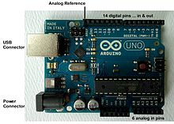](https://en.wikipedia.org/wiki/File:UnoConnections.jpg)

Magnetic Door Lock System utilizing Microcontroller [6] utilize confront acknowledgment as an instrument to bolt and open the entryway. With the quick improvement in the fields of correspondence/systems and other related remote advancements, for example, RFID (Radio Frequency Identification), UWB (Ultra Wide Band), Zigbee, NFC (Near Field Communication) and Bluetooth empower us to create different sorts of remote frameworks by means of handsets or cell phones. Investigate by [7] utilize handset and actuator for remote operation of different electrical gadgets at home. By squeezing a solitary catch on the handset, the flag is sent through the Zigbee innovation to the actuator and along these lines switches ON/OFF the planned gadget. Investigate [8] then again, exhibited a penmanship acknowledgment innovation as a security instrument to deal with a security of the entryway. Once the incapacitated client enter the penmanship on the Smartphone, the entryway will instantly opened in the wake of experiencing the procedure of ID by the framework. Specialist [9] builds up a home automation through Bluetooth on Android cell phone. This framework enables the client to bolt and open an entryway in a short range. Since Bluetooth has turned out to be so predominant in cell phones, it was viewed as a straightforward, minimal effort and secure answer for remotely associating a cell phone to a home computerization framework. In this manner, this project built up a security framework by using Bluetooth as a wireless protocol on Android Mobile Device to control just a single electrical apparatus ie. solenoid/magnetic door lock. This venture, be that as it may, concentrates on the individuals who are incapacitated from the legs up to abdomen level, in especially the individuals who utilize wheelchairs. The handicapped client can without much of a stretch utilize the Graphic User Interface (GUI) application that has been made in the Android Smartphone to bolt or open the electric door lock through Bluetooth Protocol.

**Proposed System**

We aim to build a solenoid/magnetic door lock which can be remotely controlled via Bluetooth for locking and unlocking purposes. An android based app has been developed for interacting with the door lock. A security feature like password is also provided for controlling the door lock. If the password entered by user is correct the door gets unlocked and the app shows the unlocked status. After 15 seconds the lock again get locked automatically.

Components Required:

1. Arduino Uno microcontroller board
2. HC-05 Bluetooth module
3. Power supply adapter (12 volts or higher)
4. TIP 122 transistor
5. Solderless breadboard
6. Male-to-male jumper wires
7. Android smartphone

The type of transistor we are using (the TIP122) has a base, collector, and an emitter. We will send the signal from pin 9 on the Arduino to the base of the transistor, and depending on the value sent, current will increase or decrease.

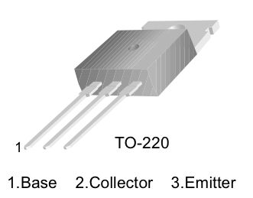

Adding a Bluetooth module is the most essential part of project. We simply connected RX on the Bluetooth module to TX on our Arduino board, TX on the module is then connected to RX on the Arduino, GND is obviously connected to ground, and lastly VCC is connected to 5 volts depending on your Bluetooth module.

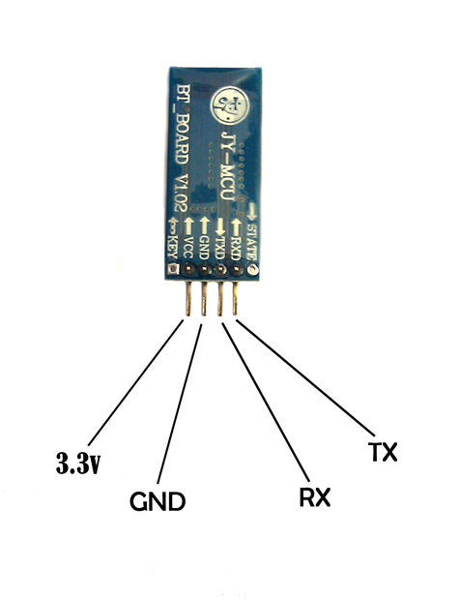

Fig. 1. Depicts the architecture of the proposed home door locks application via Bluetooth technology

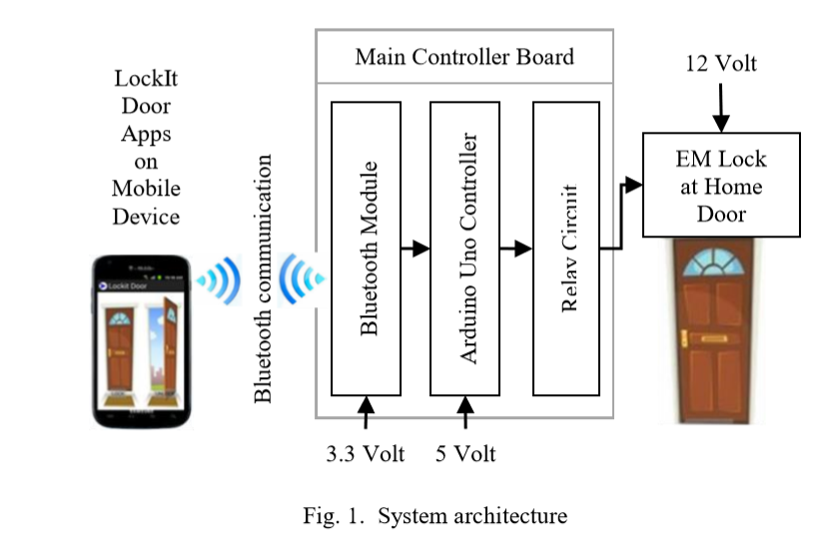

**Innovation in project**

Disabled people have a limited ability to control electrical and electronics devices (On and OFF) at their home because normally the switches are placed at an uncomfortable height for a wheelchair user. In a country like India the number of disabled friendly facilities are still minimum. Therefore, providing a very practical and user friendly android app we have tried to make their lives easier by providing remote access to the door locks that can ease accessing home without any physical contact with the door lock. Moreover there is no fear of losing the keys and a security password ensures their safety and privacy.

**Circuit Diagram**

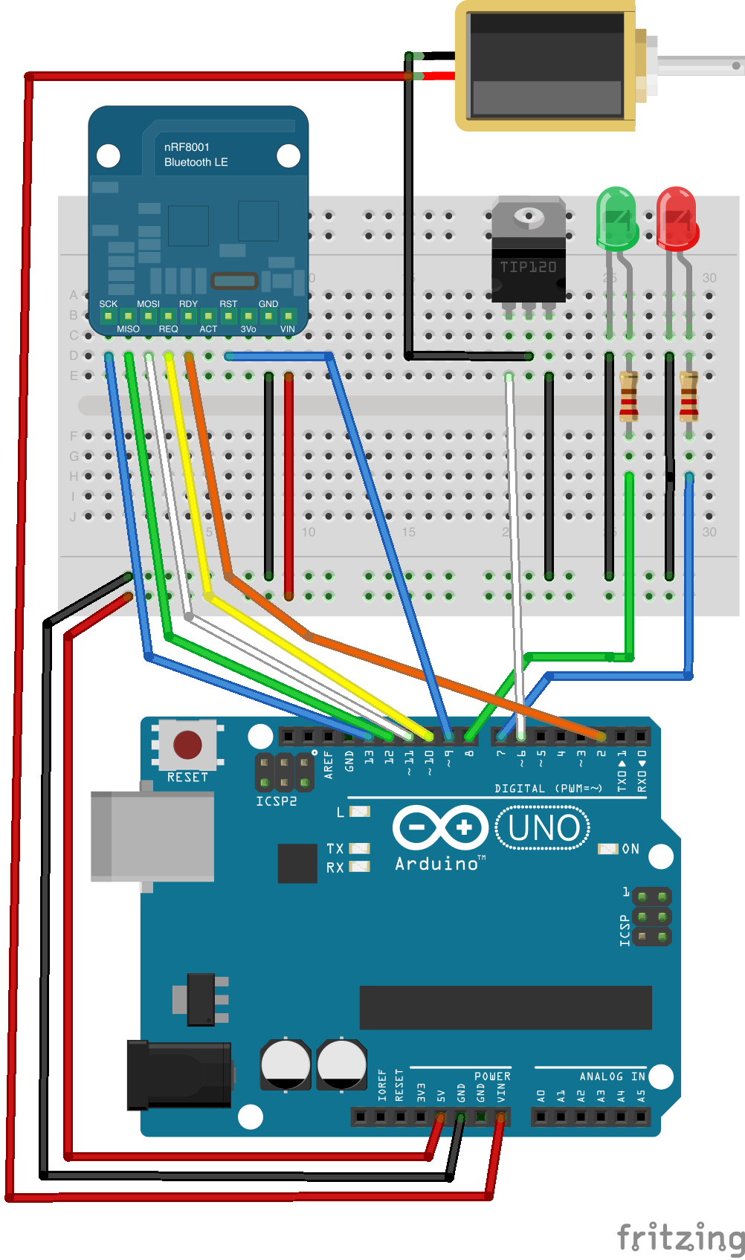

**Arduino code**

int lock = 9; //pin 9 on Arduino

char final[4]; //Characters the Arduino will receive

char correct[4] = {'A','B','C','D'}; //User-Defined Password

int pass_correct = 0; //Does Password match, 0=false 1=true

void setup()

{

pinMode(lock, OUTPUT);

Serial.begin(9600);

digitalWrite(lock, LOW); //By default, lock is active(locked)

}

void loop()

{

while(Serial.available())

{

for(int i=0; i<4; i++) //While data is available read 4 bytes

{

final[i] = Serial.read(); //Read 4 bytes into the array labled "final"

}

for(int i=0; i<4; i++)

{

if(final[i]==correct[i]) //Compare each char received to each car in our password in order

{

pass_correct = 1; //If we compare two chars and they match, set the pass_correct variable to true(1)

}

else

{

pass_correct = 0; //if the two compared chars do NOT match, set pass_correct variable to false(0)

break; //End loop and stop comparing chars

}

}

}

if(pass_correct==1) //If all chars compared match, deactivate(unlock) the lock for 5 seconds

{

Serial.println("Unlocked");

digitalWrite(lock, HIGH);

delay(15000);

Serial.println("Locked");

pass_correct = 0;

}

else

{

digitalWrite(lock, LOW); //Else if there was not a complete match, keep the lock high(locked)

}

}

**Snapshots of actual project**

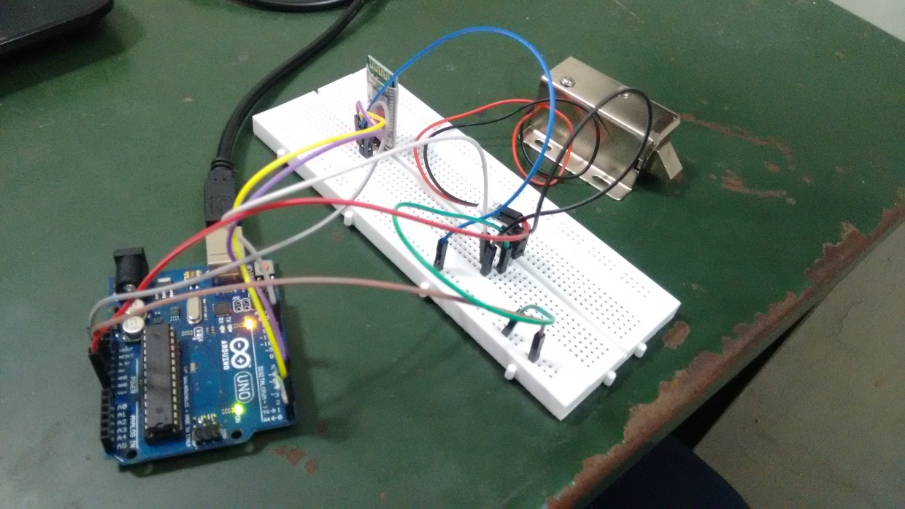

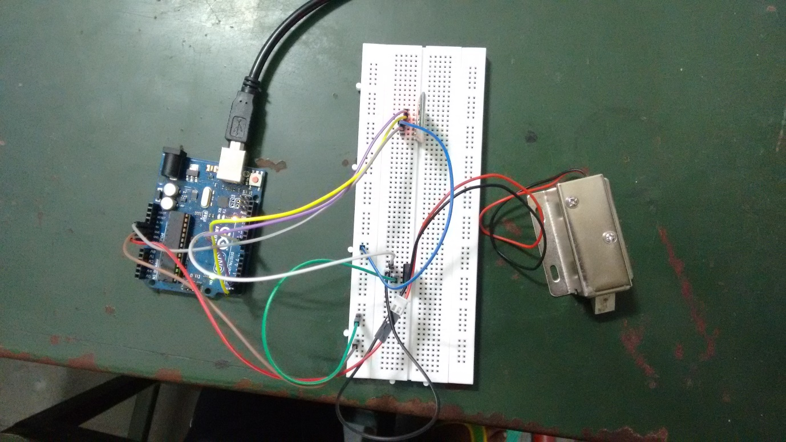

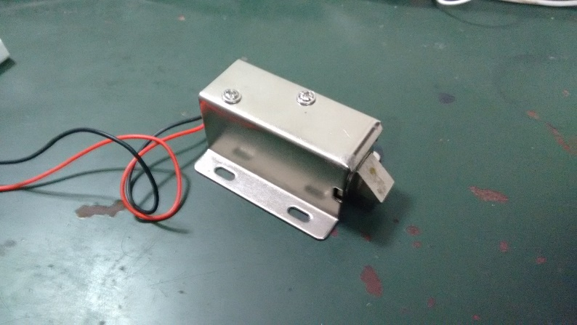

Figure 3 solenoid lock